Luis Medina
D600 Task 2
012020203

B1: Proposal of Question
For this assignment the question I am going to answer throughout the assignment is what housing features will significantly influence whether a house is classified as luxury, and would we be able to use the features to predict luxury houses in the real-world market? This question will be ideal for a real estate firm or property development company, as this analysis will give them insight into a proper property to invest in.
B2: Defined Goal
The goal for this assignment is to build and then optimize a logistic regression model to predict whether a house is considered luxury or not, based on the features. This is reasonable within the scope of the problem, because the dataset provided includes a binary outcome (IsLuxury) and relevant predictors, allowing for binary classification via logistic regression.
C1: Variable Identification
For this assignment here are the variables that would be used:
- Dependent variable: IsLuxury (binary: 0 or 1). This will be the outcome that I want to predict, to classify if a house is luxury or not.
- Independent variables: Price, Square Footage, Number of Bathrooms, Number of Bedrooms, School Rating, Distance to the City Center. The reason for these variables is that usually these are some of the factors that can classify a home as a luxury property or not. Usually, larger homes with more bedrooms and bathrooms can indicate that the price will be more expensive than smaller homes or properties. Same, with the other variables like being closer to the city will drive up the price of the property and having schools with higher ratings near the property is another factor, as family would want their kids to go to better schools.

C2: Descriptive Statistics
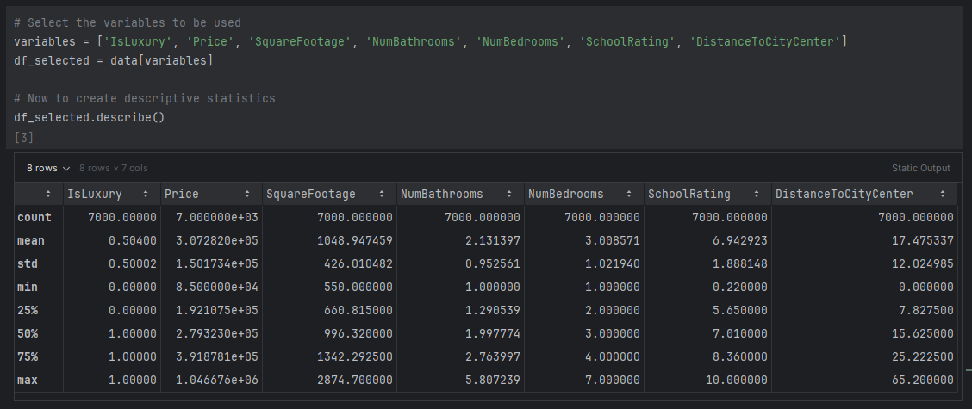
Just quickly looking at the descriptive statistics, we can see that the means and medians are similar for most of the variables, indicating a relatively normal distribution. However, variables like Price and Square Footage have a higher max compared to the mean, suggesting some high-value outliers in the dataset.
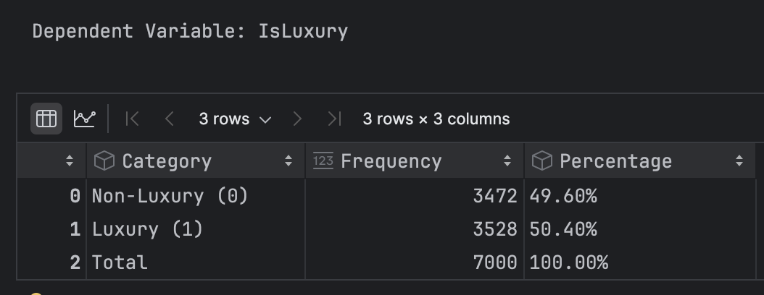

In the image above is just about the dependent variable IsLuxury and as seen in the image it shows that there are more Luxury properties than Non-Luxury by a slight amount.

C3: Visualizations
Here are the visualizations for the univariate statistics:
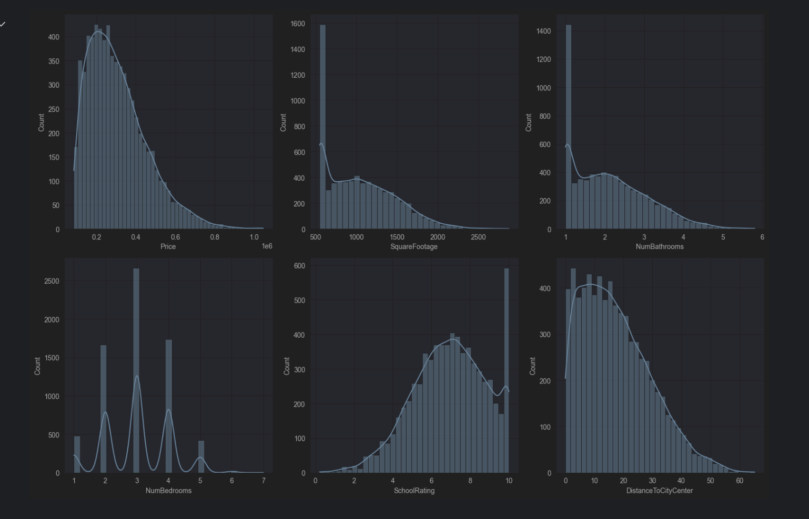
Looking at the univariate visualizations, we can see that most of the variables have a right-skewed distribution, especially Price and Square Footage. While School Rating appears to be more normally distributed. This skewness in variables like Price and Square Footage could indicate that there are a few high-value properties in the dataset, which is common in real estate data.
Here are the visualizations for bivariate statistics:
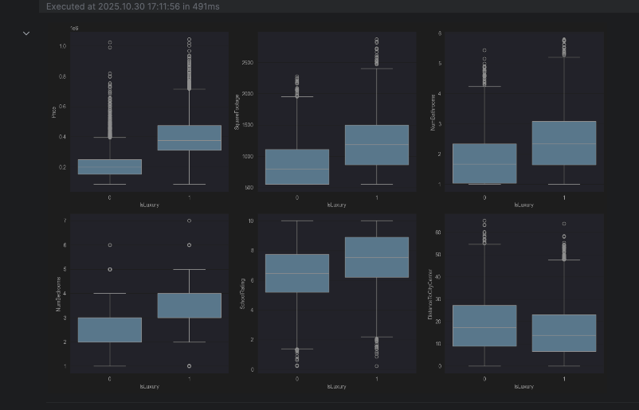
By looking at the graphs above, you can observe that luxury houses tend to have higher prices, larger square footage, more bathrooms and bedrooms, higher school ratings, and are generally closer to the city center compared to non-luxury houses.

D1: Splitting the Data
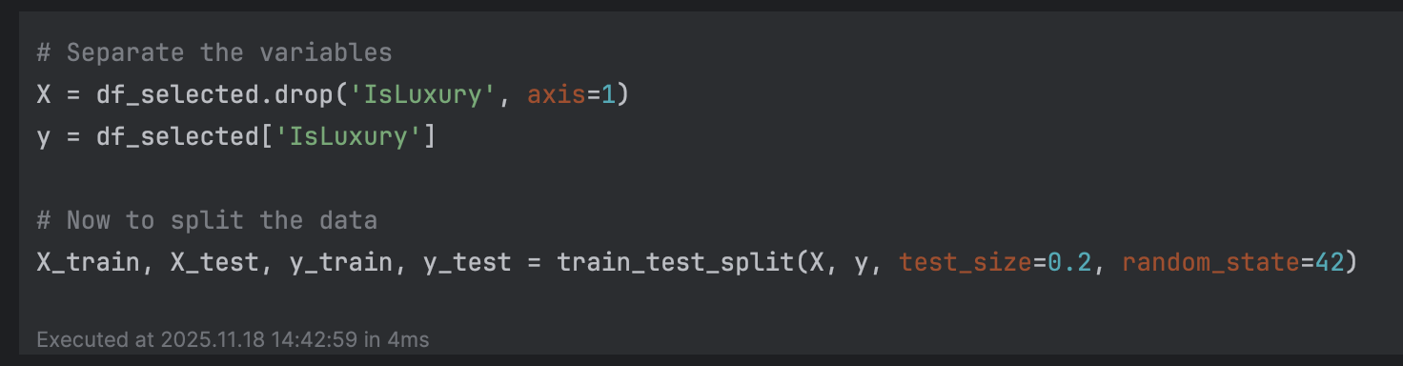
Here I just have the code snippet I used to split the data into training and testing.

D2: Model Optimization
Here is the code snippet from the model I used to optimize:
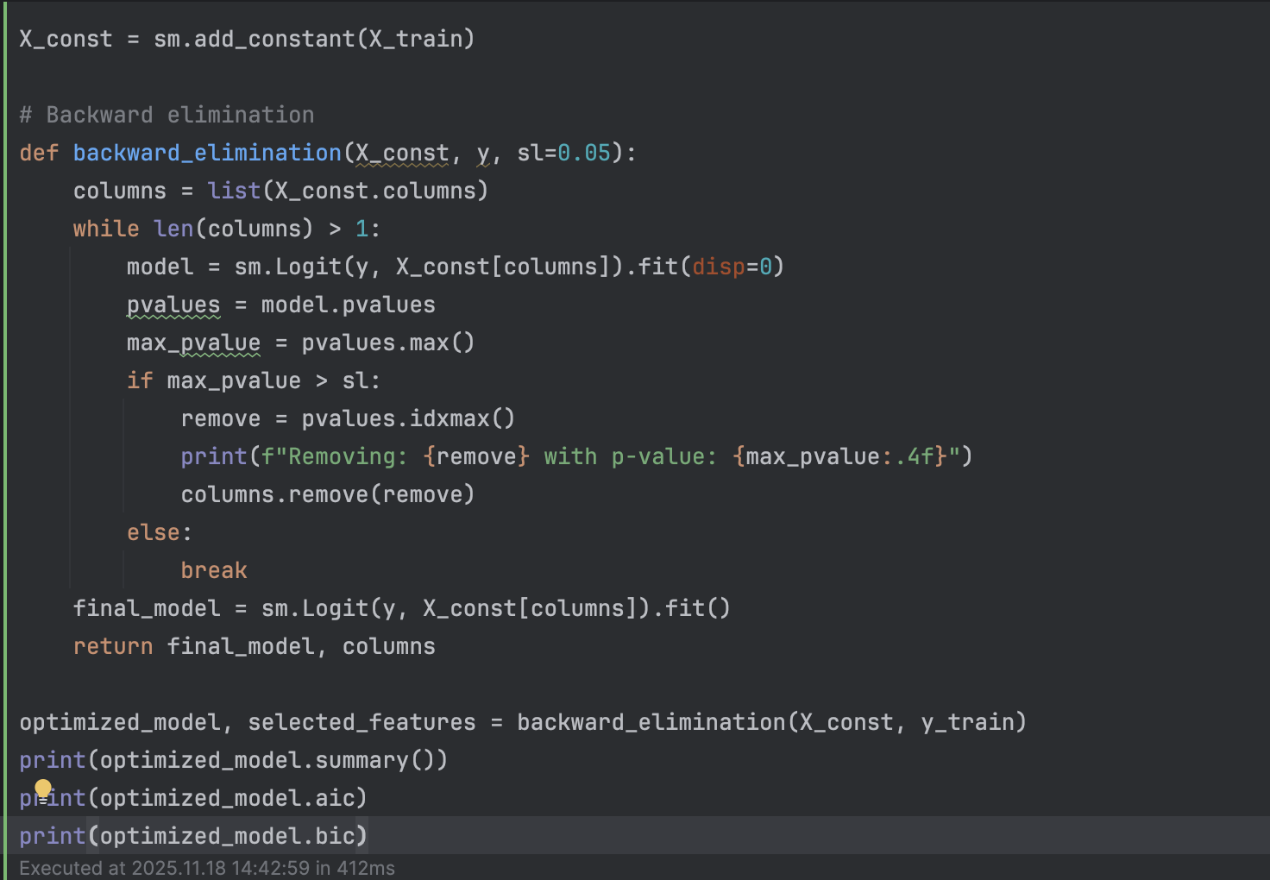

Then here are the results from the code snippet above.
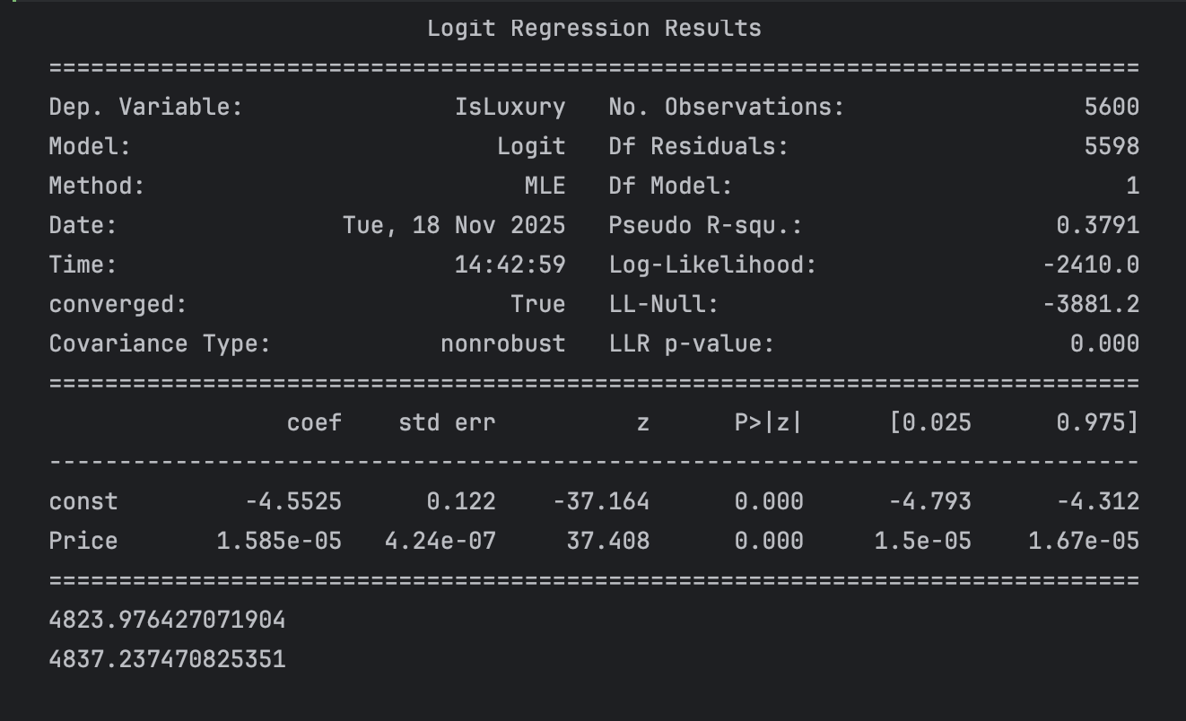

Looking at the image above, I will now get the AIC, BIC, R^2, coefficients, and p-values from the optimized model.
- AIC: 4823.97
- BIC: 4837.24
- Pseudo R-squared: 0.379
- Intercept Coefficient: -4.5525 (p-value: 0.000) and price coefficient: 0.000016 (p-value: 0.000)
D3: Confusion Matrix and Accuracy
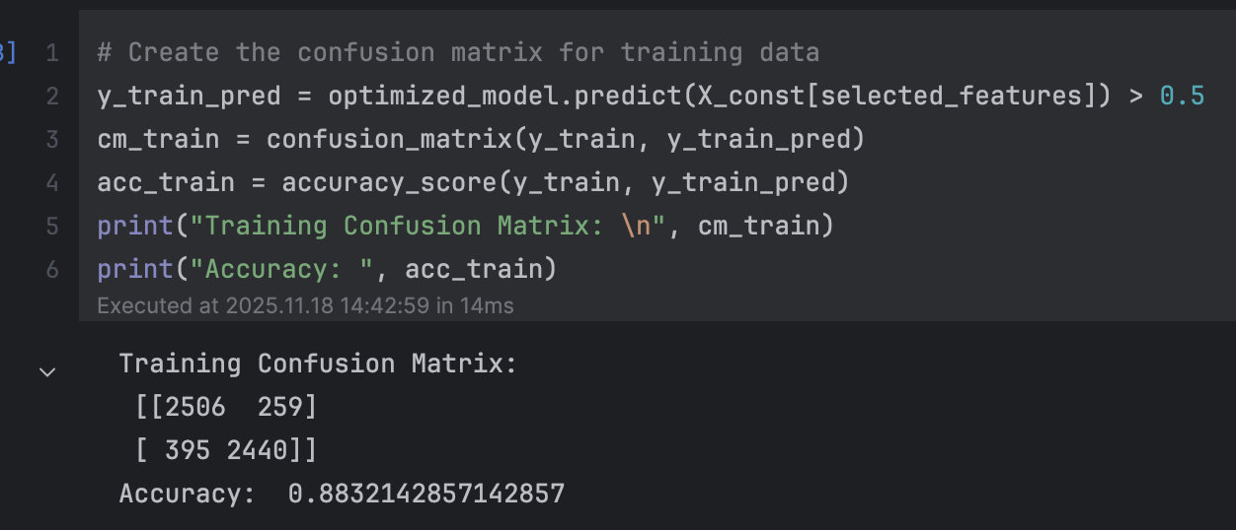
Here are a snippet of both the code and the results from the confusion matrix, along with the accuracy for the training data.

D4: Prediction
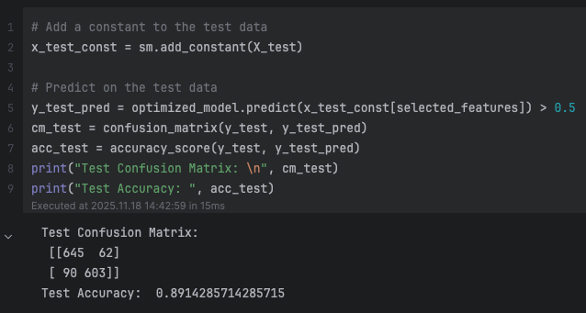
The image above shows the code snippet used to get the confusion matrix for the test data set. I also included the test accuracy above, which came out to about 89.1% for just the test data set.

E1: Packages or Libraries List
For this part of the assignment, I will list all the packages and libraries used for the assignment:
- Pandas: For loading the data from the CSV file provided.
- NumPy: For any computations used in the process of the assignment.
- Statsmodels: This was used to create the logistic regression model and pull import stats like (AIC, BIC, and p-value).
- Sklearn: This one was used to train, split the data, create the confusion matrix, and for the accuracy of the model.
- Matplotlib and Seaborn: Both packages were used to create all the visualizations you see in the images above.
E2: Optimization Method
The method I used to optimize the model was backward stepwise elimination. It starts with all the independent variables, then I fit the model, then it removes the variables with the highest p-values, and this process repeats until all the remaining independent variables have a p-value less than 0.05.
E3: Method Justification
The reason for using backward elimination is that it’s effective for feature selection in logistic regression models. It starts with the full model, so it does not avoid any import variables and then it starts removing insignificant variables. By doing all this, it helps reduce overfitting, improve model interpretability, and enhance predictive performance like AIC/BIC.
E4: Assumption Summary
Here I will summarize at least four assumptions of the logistic model:
- Binary Outcome: The dependent variable is binary (0/1).
- Linearity of Logit: There is a linear relationship between the logit of the outcome and each predictor variable.
- Independence of observations: No autocorrelation or dependence among observations.
- No multicollinearity: Independent variables are not highly correlated with each other.
E5: Verification of Assumptions
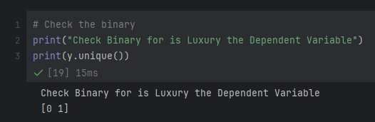
The image above shows that the binary outcome is in fact binary for the first assumption from the previous section.
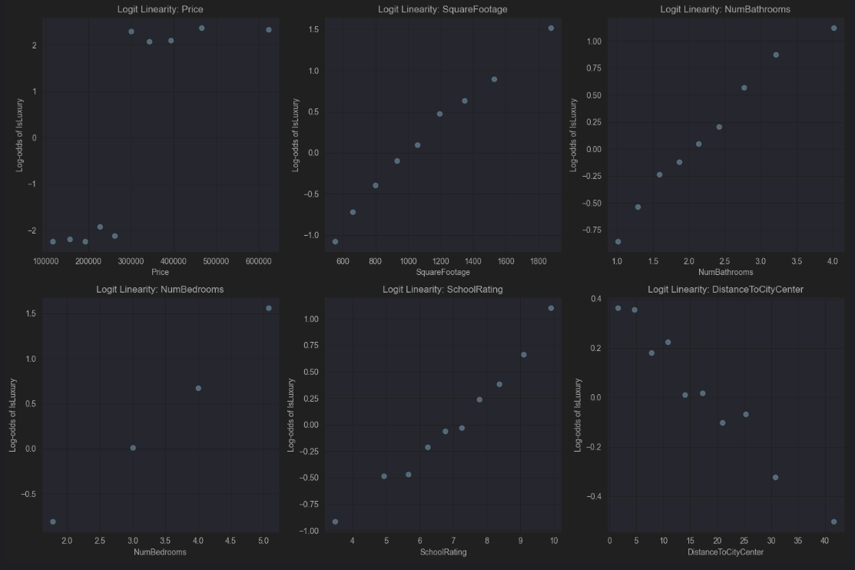
For the second assumption, here are the graphs showing strong linear trends with all the variables. Therefore, the assumption is satisfied.
Then, for the third assumption, Independence of Observations, each row in the dataset represents a unique house. There is no clustering, repeated measures, or time-series structure in the dataset, and the observations are independent. Therefore, the assumption is satisfied.
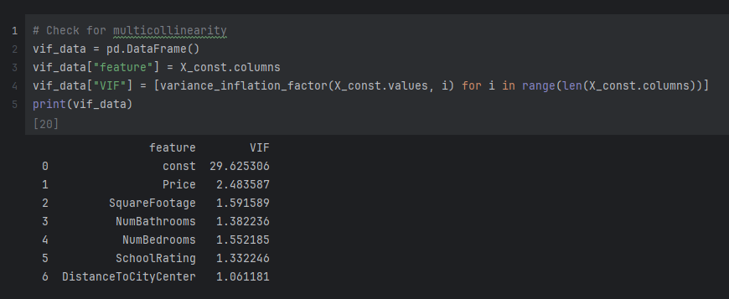
In the image above it has the code snippet and results from looking at the VIF for all the variables and as we can see from the results all VIF values for predictors are well below 5, so the assumption is satisfied.
E6: Equation
The final equation for that I got for the optimized model is as follows:
Logit(P) = -4.5525 + 0.00001585 Price, where p is the probability of the house being luxury, -4.5525 is the intercept and 0.00001585 is the coefficient for price. The price coefficient is positive, meaning that as price increases, the likelihood of it being classified as Luxury increases. The low p-value from above confirms that this relationship is statistically significant and not due to random chance. Here the value 0.00001585 means, that the change in the log-odds of a house being luxury for every $1 increase in price. The reason the coefficient is so small is because an increase of $1 in price is a very small unit. The intercept, which is –4.5525, represents the log-odds of a house being luxury if the price were $0. As we know, houses with a price of $0 cannot be considered luxury.

E7: Model Metrics
The accuracy for the test dataset was 89.1% and the accuracy for the training dataset was 88.3%. Looking at results from both datasets, we can see that the accuracy slightly increased, meaning good generalization, and it’s great to know that the model performs well with new data. Now to compare the confusion matrices from both the testing and training datasets, we have similar proportions of false positives and false negatives, indicating consistent performance across datasets.

E8: Results and Implications
The analysis revealed that Price is an overwhelming predictor of Luxury status in this dataset. While other factors like size and location matter, they are likely already captured within the Price. The model is highly effective at distinguishing luxury homes based on prices alone.

E9: Course of Action
Based on the finding from the analysis, the first step is to deploy and use the logistic regression model to automatically flag “Luxury” properties in the company’s database for targeted marketing campaigns. Then since Price is the key driver, the firm should analyze properties that are predicted as “Luxury” but have a lower actual price. These properties may be undervalued and represent excellent investment opportunities.

G: Sources
No sources were used; the only thing used was the material provided by the course.

